HOME SERVICES BOOKING APP

Project Documentation

B.Tech – Computer Science Engineering

1. Introduction
The Home Services Booking App is a web-based application designed to help customers easily find and book professional home services through a single platform. It provides various household services, such as plumbing, electrical repairs, cleaning, appliance repair, painting, carpentry, AC repair, and pest control.
The application allows users to register and log in, browse available services, search and filter services based on their requirements, and view service provider details, ratings, and reviews. Customers can select a suitable service provider, choose a convenient date and time, enter their address, and confirm their bookings. They can also track booking status, view booking history, cancel or reschedule appointments, receive notifications, and communicate with service providers.
The application is developed using HTML, CSS, JavaScript, and React, with browser Local Storage used to store user details and booking information. The project is divided into three main modules: Service Discovery and Provider Management, Booking and Booking Management, and User, Notification and Communication.
The main objective of this project is to provide a simple, user-friendly, and convenient platform that saves customers time and makes managing household service requirements easier and more efficient.

2. Problem Statement
Finding and booking reliable home services can be difficult and time-consuming for customers. People often need to contact different service providers individually to arrange services such as plumbing, electrical repairs, cleaning, appliance repair, painting, and other household tasks. Comparing service prices, checking provider ratings, confirming availability, and scheduling appointments can also be inconvenient.
The Home Services Booking App aims to solve these problems by providing a centralized web-based platform where customers can easily find suitable home services and book appointments according to their requirements. The application allows users to view service details, compare providers, check ratings and reviews, select a convenient date and time, and manage their bookings.
The system also provides features such as booking status tracking, booking history, cancellation, rescheduling, notifications, and communication between customers and service providers. The main goal is to simplify the home service booking process, reduce the time and effort required, and provide a convenient and user-friendly experience.

3. Objectives
The main objectives of the project are:
- To provide a centralized platform for booking home services.
- To allow users to register and log in securely at the interface level.
- To display different home service categories.
- To provide search and filtering options for services.
- To display service provider details, ratings, and reviews.
- To allow customers to select a suitable date and time.
- To provide booking confirmation and booking status tracking.
- To allow users to cancel or reschedule appointments.
- To maintain booking history.
- To provide notifications and customer-provider communication.
- To display service charges and payment options.
- To store user and booking information using Local Storage in the prototype.

4. Scope of the Project
The scope of the Home Services Booking App includes the development of a web-based platform for discovering, booking, and managing household services.
The application covers services such as:
- Plumbing
- Electrical repairs
- Home cleaning
- Appliance repair
- Painting
- Carpentry
- AC repair
- Pest control
Customers can browse available services, view provider information, check ratings and reviews, select appointment dates and times, enter their addresses, and confirm bookings.
The system also supports booking history, cancellation, rescheduling, notifications, user profile management, and a simulated payment interface.
The project is developed as a frontend application using HTML, CSS, JavaScript, and React. Local Storage is used for prototype data persistence. A backend database and real payment gateway can be added in future development.

5. Target Users
The main users of the application are:
1. Customers: Browse services, compare providers, book appointments, manage bookings, and submit reviews.
2. Service Providers: View booking requests, manage availability, update service status, and communicate with customers.
3. Administrators: In a future extended version, manage users, service categories, providers, bookings, and complaints.
4. Home Service Businesses: Use booking information to organize appointments and manage customer requirements.

6. Core Concept of the Home Services Booking App
The central concept of this project is to bring different household services together on one platform instead of requiring customers to contact multiple providers separately.
For example, if a customer needs AC repair, they can open the application, select the AC Repair category, view available service providers, compare their ratings and prices, choose a convenient appointment, enter their address, and confirm the booking.
The customer can then view the booking details and track the booking status through the application.

7. System Modules
The project is divided into three major modules.

Module 1: Service Discovery and Provider Management
This module helps customers find suitable home services and service providers.
Main functions:
- Display the home page and service categories.
- Search for available services.
- Filter services by category, price, rating, and availability.
- Display service descriptions and starting prices.
- Show provider details and experience.
- Display customer ratings and reviews.
- Help customers compare service options.

Module 2: Booking and Booking Management
This module handles the creation and management of service appointments.
Main functions:
- Select a service and service provider.
- Select a suitable date and time.
- Enter the customer's address and contact details.
- Display the booking summary.
- Confirm a booking.
- Generate and display a booking ID.
- View booking details and status.
- Cancel or reschedule appointments.
- Maintain booking history.

Module 3: User, Notification and Communication

This module manages user information, booking notifications, and customer-provider communication.
Main functions:
- User registration and login.
- Profile management.
- Display booking-related notifications.
- Provide a simulated chat interface.
- Display payment details and available payment methods.
- Show booking confirmation and status updates.

8. Functional Requirements
The system should provide the following functionalities:
- User registration and login.
- Service listing and category selection.
- Service search and filtering.
- Provider details and ratings.
- Appointment date and time selection.
- Booking confirmation.
- Booking status tracking.
- Booking cancellation and rescheduling.
- Booking history management.
- Notifications for booking updates.
- Customer-provider communication.
- Payment information display.
- Local Storage for prototype data.
- Form validation and error messages.

9. Data Requirements
The application maintains the following information:
Data | Details
User details | Name, email, phone number and profile information
Service details | Service ID, name, category, description and price
Provider details | Provider name, experience, rating and availability
Booking details | Booking ID, service, provider, date, time and address
Booking status | Pending, Confirmed, In Progress, Completed or Cancelled
Reviews | Rating and customer comments
Notifications | Notification message, date and type
Payment details | Service amount, charges and payment method

10. Technology Requirements

Technology | Purpose
HTML5 | Creates the structure of web pages and forms.
CSS3 | Provides styling, layout and responsive design.
JavaScript | Handles validation, search, filtering and booking logic.
React | Builds reusable components and dynamic interfaces.
Browser Local Storage | Stores prototype user and booking information.
Visual Studio Code | Used to develop and edit the application.
Google Chrome / Edge | Used to run and test the application.

11. System Flow

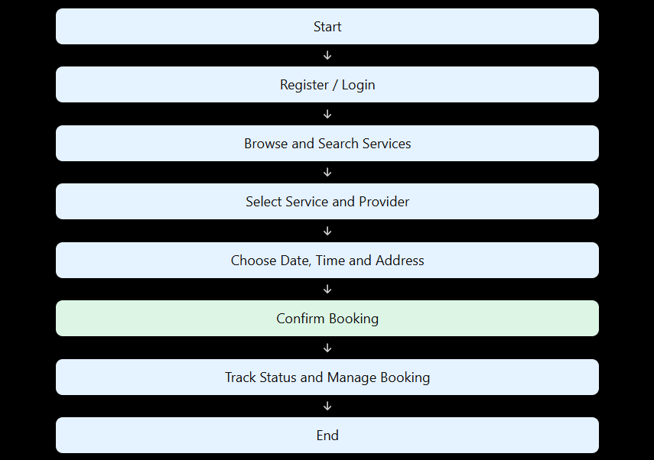

Advantages of the Proposed System

• Saves time and effort when finding home services.
• Provides multiple service categories in one place.
• Makes it easier to compare providers and ratings.
• Simplifies appointment scheduling.
• Allows customers to manage bookings conveniently.
• Provides booking status updates and notifications.
• Maintains booking history.
• Improves communication between customers and providers.
• Can be expanded with a backend database and real payment integration.

Future Enhancements

The application can be improved in the future by adding:
- A centralized backend database.
- Secure authentication and role-based access.
- Real-time service provider availability.
- GPS-based provider location and map integration.
- A real payment gateway supporting UPI, cards, and other methods.
- Live booking notifications.
- A real-time chat system.
- Customer reviews after service completion.
- An administrator dashboard.
- Provider verification and document management.
- Automatic booking reminders.
- Reports and analytics for service bookings.

14. Conclusion

The Home Services Booking App provides a convenient platform for finding, booking, and managing household services. It brings services such as plumbing, electrical repairs, cleaning, appliance repair, painting, and AC repair together in one application.
The system allows customers to search for services, compare providers, schedule appointments, track booking status, and manage their booking history. The three modules organize the application into service discovery, booking management, and user communication.
By using HTML, CSS, JavaScript, React, and Local Storage, the project demonstrates the main workflow of a home services booking platform. Future improvements, such as backend integration, secure authentication, GPS tracking, and real payment processing, can make the system suitable for a more complete real-world application.

